AUTONOMOUS RESEARCH INTELLIGENCE SYSTEM

A PROJECT REPORT
Submitted by

Vidhya V | RA2211003020335
Jeyadeepak U R | RA2211004020341
Dhanarajan K | RA2211003020347

Under the guidance of
Dr. R. Nagalakshmi
Assistant Professor,
Department of Computer Science and Engineering
in partial fulfillment for the award of the degree of
BACHELOR OF TECHNOLOGY
in
COMPUTER SCIENCE AND ENGINEERING

of
FACULTY OF ENGINEERING AND TECHNOLOGY


SRM INSTITUTE OF SCIENCE AND TECHNOLOGY RAMAPURAM, CHENNAI -600089

May 2026

SRM INSTITUTE OF SCIENCE AND TECHNOLOGY
(Deemed to be University U/S 3 of UGC Act, 1956)

BONAFIDE CERTIFICATE

Certified that this project report titled “AUTONOMOUS RESEARCH INTELLIGENCE SYSTEM” is the bonafide work of VIDHYA V [REG NO: RA2211003020335], JEYADEEPAK U R [REG NO: RA2211003020341], DHANARAJAN K [REG NO: RA2211003020347] who carried out the project work under my supervision. Certified further, that to the best of my knowledge, the work reported herein does not form any other project report or dissertation on the basis of which a degree or award was conferred on an occasion on this or any other candidate.

SIGNATURE | SIGNATURE
Name of the Supervisor Designation  Name of the Department,  SRM Institute of Science and Technology, Chennai-89. | Name of the HoD Professor and Head  Computer Science and Engineering,  SRM Institute of Science and Technology, Chennai-89.

Submitted for the project viva-voce held on at SRM Institute of Science and Technology, Chennai -600089.

INTERNAL EXAMINER EXTERNAL EXAMINER

SRM INSTITUTE OF SCIENCE AND TECHNOLOGY RAMAPURAM, CHENNAI - 89

DECLARATION

We hereby declare that the entire work contained in this project report titled

“AUTONOMOUS RESEARCH INTELLIGENCE SYSTEM”
has been carried out by VIDHYA V [REG NO: RA2211003020335], JEYADEEPAK U R [REG NO: RA2211003020341], DHANARAJAN K [REG NO: RA2211003020347] at SRM Institute of Science and Technology, Ramapuram, Chennai- 600089, under the guidance of Dr. R. Nagalakshmi, Assistant Professor, Department of Computer Science and Engineering.

Place: Chennai | Vidhya V
Date: | Jeyadeepak U R
 | Dhanarajan K


Own Work Declaration

Department of Computer Science and Engineering

SRM Institute of Science and Technology Own Work Declaration form
Degree/ Course : B. Tech Computer Science and Engineering
Student Name : Vidhya V, Jeyadeepak U R, Dhanarajan K
Registration Number : RA2211003020335, RA2211003020341, RA2211003020347
Title of Work : Autonomous Research Intelligence System
We hereby certify that this assessment complies with the University’s Rules and Regulations relating to Academic misconduct and plagiarism, as listed in the University Website, Regulations, and the Education Committee guidelines.
We confirm that all the work contained in this assessment is our own except where indicated, and that We have met the following conditions:
- Clearly references / listed all sources as appropriate
- Referenced and put in inverted commas all quoted text (from books, web, etc)
- Given the sources of all pictures, data etc. that are not our own
- Not made any use of the report(s) or essay(s) of any other student(s) either past or present
- Acknowledged in appropriate places any help that we have received from others (e.g., fellow students, technicians, statisticians, external sources)
- Compiled with any other plagiarism criteria specified in the Course handbook / University website
We understand that any false claim for this work will be penalised in accordance with the University policies and regulations.

DECLARATION:
We are aware of and understand the University’s policy on Academic misconduct and plagiarism and we certify that this assessment is our own work, except where indicated by referring, and that we have followed the good academic practices noted above.
RA2211003020335 RA2211003020341 RA2211003020347

ACKNOWLEDGEMENT

We thank the Almighty for giving us the strength and guidance to successfully complete this project. We place on record our deep sense of gratitude to our honourable Chairman Dr. R. SHIVAKUMAR, MBBS., MD., for providing us with the requisite infrastructure throughout the course.
We take the opportunity to extend our hearty and sincere thanks to our Dean, Dr. M. SAKTHI GANESH., Ph.D., for guiding us towards the successful completion of the project.
We take the privilege to extend our hearty and sincere gratitude to the Professor and Head of the department, Dr. K. RAJA, Ph.D., for his suggestions, support and encouragement towards the completion of the project with perfection.
We express our hearty and sincere thanks to our guide Dr. R. Nagalakshmi, Assistant Professor, Department of Computer Science and Engineering for his/her encouragement, motivation and constant guidance throughout this project work.
Our thanks to the teaching and non-teaching staff of the Department of Computer Science and Engineering of SRM Institute of Science and Technology, Chennai, for providing necessary resources for our project.
We also thank our team members for their cooperation, coordination, and support throughout the project. We extend our gratitude to our parents and family members for their continuous support and encouragement

ABSTRACT

The Autonomous Research Intelligence System (ARIS) is a modular Python framework designed to automate the full lifecycle of structured research, from document ingestion to knowledge synthesis and research planning. It addresses key limitations in existing AI tools by ensuring determinism, interpretability, and reproducibility. Unlike black-box models, ARIS produces fully explainable outputs using explicit logic. This makes it a reliable and trustworthy system for research environments that demand accuracy and transparency.

ARIS is architecturally divided into two phases to balance stability and scalability. Phase 1, which is production-ready, includes ten modules that handle validation, reasoning, evaluation, trace logging, document processing, and knowledge graph creation. Each module operates deterministically to ensure consistent outputs. Phase 2 introduces planned machine learning extensions like SciBERT and clustering techniques, which are isolated and do not affect the core system’s behavior.

The system is built using Python 3.11 with strict type checking and a comprehensive test suite to ensure reliability. ARIS guarantees reproducibility, traceability, and immutability while avoiding autonomous execution loops. Its design supports transparent and auditable workflows, making it suitable for high-stakes research applications. Overall, ARIS provides a strong and dependable foundation for future AI-driven research systems.

TABLE OF CONTENTS

 | Page No.
ABSTRACT | vi
LIST OF FIGURES | ix
LIST OF TABLES | x
LIST OF ACRONYMS AND ABBREVATIONS | xi
- INTRODUCTION  - Background of the study  - Problem Statement  - Aim of the project  - Scope of the project  - Project domain  - Organization of the report | 1  1  2  2  3  4  4
- LITERATURE REVIEW  - Overview  - Automated research synthesis and planning  - Deterministic and interpretable ai  - Document ingestion and corpus management  - Comparative analysis | 5  5  5  6  6  7
- PROJECT DESCRIPTION  - Existing System  - Proposed System  - Advantages  - Feasibility Study  - Economic Feasibility  - Technical Feasibility  - Social Feasibility  - System Specification  - Hardware Specification  - Software Specification | 8  8  8  9  10  10  10  10  11  11  11
- PROPOSED WORK  - General Architecture  - Design Plan  - Data Flow Diagram  - Algorithm Description  - Link materialisation algorithm  - Research planning algorithm | 12  12  13  15  16
- IMPLEMENTATION AND TESTING  - Tools and Technologies Used  - Key Implementation Details  - Types of Testing  - Thread - safe memorystore  - Deterministic uuid generation  - Evidence - complete edge creation  - Test Architecture  - Test Methodology  - Functional Testing  - Module - level isolation testing  - Performance evaluation  - Type checking and linting  - Input and output demonstration | 17  17  17  17  18  18  19  19  19  20  20  21  21  22
- RESULTS AND DISCUSSIONS  - Performance evaluation summary  - Functional correctness results  - Knowledge graph quality metrics  - Comparison with existing system  - Discussion | 23  23  23  24  24  25
- CONCLUSION AND FUTURE WORK  - Summary of work  - Key Findings  - Future Enhancements  - Phase 2 implementation (near - term)  - Web interface and visualization (medium - term)  - Multi - user collaboration research (medium - term)  - Patent application (planned)  - Domain - specific deployments | 26  26  26  27  27  27  28  28  28
References | 29
APPENDIXES  - Sample Source Code  - Screenshots  - Proof of Publication/Patent Files/Conference Certificate | 34  34

LIST OF FIGURES

4.1 | Architecture Diagram | 13
4.2 | Data Flow Diagram | 14
5.1 | Document Ingestion | 22
5.2 | Knowledge Graph View | 22

LIST OF TABLES

Table No. | Table Name | Page No.
2.1 | Comparative Analysis | 8
3.1 | Hardware Requirement | 12
3.2 | Software Requirement | 12
5.1 | Tools And Technologies | 19
5.2 | Test Architecture | 21
5.3 | Phase1 Performance | 22
6.1 | Functional Results | 25
6.2 | Knowledge Graph Quality Metrics | 26
6.3 | Comparison Existing System | 26

LIST OF ACRONYMS AND ABBREVIATIONS

ARIS | AUTONOMOUS RESEARCH INTELLIGENCE SYSTEM
AI | ARTIFICIAL INTELLIGENCE
KG | KNOWLEDGE GRAPH
ML | MACHINE LEARNING
API | APPLICATION PROGREMMING INTERFACE

CHAPTER 1

INTRODUCTION

The increasing volume of research data and technical documents has made it challenging for researchers to efficiently process, connect, and extract meaningful insights. Traditional methods are time-consuming, while many modern AI-based tools lack transparency and produce non-reproducible results. This creates a need for systems that can provide reliable, explainable, and structured research support.

The Autonomous Research Intelligence System (ARIS) is designed to address these challenges by offering a deterministic and modular framework for research intelligence. It processes unstructured data and converts it into structured, evidence-backed knowledge representations. Unlike black-box AI systems, ARIS ensures that every step of reasoning and decision-making is fully traceable. By combining document ingestion, logical reasoning, evaluation, and knowledge graph construction, ARIS enables researchers to gain clear and auditable insights. Its design focuses on reproducibility, transparency, and control, making it suitable for academic, industrial, and high-stakes research environments.

  - BACKGROUND OF THE STUDY

The rapid growth of scientific literature and multi-domain research has created a significant challenge, making it difficult for researchers to efficiently analyse and connect relevant information. Existing AI tools, including large language models and retrieval systems, provide limited support due to their lack of transparency and non-deterministic behaviour. These systems often fail to offer clear, traceable justifications for their outputs. In research environments, especially critical ones, every conclusion must be supported by verifiable evidence.

ARIS (Autonomous Research Intelligence System) was developed to address this gap by introducing a fully deterministic and explainable research framework. It relies on explicit logic instead of black-box models, ensuring that every reasoning step and outcome is traceable and reproducible. Its architecture is inspired by interpretable AI, functional programming, and contract-driven design principles. This makes ARIS reliable and suitable for academic and high-stakes research applications requiring transparency and trust.

PROBLEM STATEMENT
Researchers and knowledge workers face multiple challenges when working with large-scale document collections. These challenges affect the efficiency, reliability, and trustworthiness of research processes.
Key Problems:
- Disconnected Information Silos: Related insights across multiple documents remain unlinked due to the lack of reliable and transparent systems for identifying cross-document relationships.
- Non-Reproducible AI Outputs: Most AI-based tools generate different results for the same input, making it difficult to validate or trust their conclusions.
- Lack of Evidence Trails: Many knowledge graph systems create relationships without providing clear supporting evidence, reducing auditability and credibility.
- Premature Autonomy Risks: Some AI systems perform actions without human control, which can lead to errors in academic or professional environments.
- Tightly Coupled ML Dependencies: Systems that depend heavily on machine learning models may become unstable, as updates can silently change outputs and behavior.

AIM OF THE PROJECT
The primary aim of ARIS is to develop a production-grade, fully auditable research intelligence system that converts unstructured documents into structured, evidence-backed knowledge graphs and actionable research plans, while maintaining reproducibility and interpretability.
Objectives:
    - Design a deterministic document ingestion and validation pipeline for handling text and PDF inputs.

    - Build a template-driven reasoning engine that generates traceable and reproducible multi-step reasoning.
    - Implement a four-dimensional evaluation system to assess reasoning quality based on step count, coherence, confidence alignment, and input coverage.
    - Develop a knowledge graph module with evidence-backed and immutable relationships between documents.
    - Create a research planning module that identifies gaps, contradictions, and weak evidence without executing actions autonomously.
    - Implement a trace replay system to reconstruct and audit past executions from stored memory.
    - Ensure strict type safety (mypy) and maintain a robust test suite with 233+ passing tests.

SCOPE OF THE PROJECT

ARIS Version 1.0 (Phase 1, Sealed) defines a deterministic and auditable framework for research intelligence, covering document processing, reasoning, evaluation, and knowledge synthesis within a controlled environment.

In Scope:
- Document Support: Handles plain text (.txt) and PDF (.pdf) files for structured ingestion and processing.
- Knowledge Graph Construction: Enables node creation from document corpora, deterministic link generation, and evidence-backed edge formation.
- Research Planning: Supports gap detection, contradiction analysis, and weak-evidence refinement strategies.
- Tool Interface: Provides a registry-based abstraction with built-in tools (e.g., echo, word count) and extensibility for additional tools.
- Trace Persistence: Stores execution traces in memory and JSON files for complete replay and auditability.

- Comparative Analysis: Allows parallel execution of the same input across multiple configurations for analysis and testing.

PROJECT DOMAIN

The development of ARIS follows a contract-driven, phase-gated methodology to ensure reliability and control. Phase 1 is built entirely without machine learning dependencies, using deterministic Python logic for reasoning, evaluation, and planning. Each module is defined through formal contracts that specify allowed and restricted behaviors. The system enforces immutability of inputs and prevents autonomous execution, ensuring full traceability and governance.

Phase 2 extends the system by introducing machine learning components through the tool abstraction layer. These models are treated as optional tools, and their outputs are processed through Phase 1 reasoning and evaluation mechanisms. This ensures that all results remain evidence-backed and auditable. Even with ML integration, the system maintains transparency and does not compromise its deterministic foundation.

ORGANISATION OF THE REPORT

This report is organized into multiple chapters to provide a structured understanding of the ARIS system. Chapter 2 presents a review of related work in knowledge graph construction, automated research synthesis, and deterministic AI systems. Chapter 3 discusses system analysis and design, including the existing system, proposed solution, feasibility study, and technical specifications. Chapter 4 explains the system architecture and methodology, covering module design, data flow, algorithms, and future ML extensions.
Chapter 5 focuses on the implementation details, including the development environment, key code components, and testing strategies. Chapter 6 presents the results, performance evaluation, and comparative analysis of the system. Finally, Chapter 7 concludes the report and highlights possible future enhancements and research directions.

CHAPTER 2

LITERATURE REVIEW

OVERVIEW

This chapter reviews the existing research and technologies relevant to the development of ARIS across multiple domains. It focuses on key areas such as knowledge graph construction and linking, automated research synthesis and planning, deterministic and interpretable AI systems, and document ingestion techniques. These domains collectively form the foundation for building structured and reliable research intelligence systems.

Each section of this chapter also highlights the limitations and gaps present in current approaches. These gaps provide the motivation for the design and development of ARIS. By analysing existing methods, this chapter establishes the need for a deterministic, transparent, and reproducible research framework.

AUTOMATED RESEARCH SYNTHESIS AND PLANNING

Automation in research synthesis has been explored through systematic review tools such as Covidence and Rayyan, along with AI-based summarisation systems built on transformer models. Techniques like SciERC enable scientific entity recognition and relation extraction, while models such as SciBERT improve performance across various scientific NLP tasks. These approaches help in processing large volumes of research data but often rely on probabilistic methods that lack full transparency.

Research planning, however, remains less developed, especially in terms of control and auditability. Many agent-based systems combine planning with execution, automatically performing actions without sufficient human oversight. This can lead to risks in academic and professional contexts. ARIS addresses this limitation by clearly separating planning from execution, where the system only suggests structured research actions with supporting evidence, ensuring transparency and maintaining complete human control.

DETERMINISTIC AND INTERPRETABLE AI

The field of interpretable AI (XAI) focuses on making AI systems more understandable through techniques such as LIME and SHAP, as well as inherently interpretable models like decision trees and rule-based systems. However, most of these approaches aim to explain the outputs of complex black-box models after they are generated. This means the core decision-making process often remains non-deterministic and difficult to fully verify.

In contrast, ARIS adopts a fundamentally different approach by building determinism and interpretability directly into the system design. Instead of relying on post-hoc explanations, it ensures that every output is generated through explicit, traceable logic. This allows every claim or relationship to be verified against the underlying code, providing stronger guarantees of transparency and reliability while maintaining practical applicability.

DOCUMENT INGESTION AND CORPUS MANAGEMENT

Document ingestion and corpus management have been widely studied in digital libraries, semantic web systems, and modern data processing frameworks. Tools such as Apache Tika and Unstructured.io are commonly used for extracting and processing data from various formats. However, handling PDF documents remains challenging due to issues like layout preservation and inconsistent formatting.

ARIS improves upon these approaches by incorporating a structured and traceable ingestion process within its framework. It uses pypdf as an optional dependency for PDF handling while ensuring that every document is associated with clear provenance metadata, including source, format, and unique identifiers. This ensures better traceability, consistency, and reliability in managing research corpora compared to many existing ingestion systems.

COMPARATIVE ANALYSIS

This comparative analysis demonstrates that ARIS occupies a unique position in the research intelligence landscape: it is the only system that combines full determinism, evidence-complete knowledge graphs, and safe ML extensibility under a formal governance contract.

Aspect | Neural KG Systems | AutoGPT / Agentic Tools | ARIS Phase 1
Determinism | No (stochastic) | No (LLM-based) | Yes (fully deterministic)
Evidence on edges | No (embedding-based) | Partial (generated text) | Yes (reasoning traces)
Autonomy control | N/A | Executes autonomously | Proposes only, no execution
ML dependencies | Heavy | Heavy (GPT-4/3.5) | Zero (stdlib only)
Test coverage | Varies | Low | 233 tests, all passing
Reproducibility | Low | Low | Guaranteed (sealed contract)
Phase 2 ML isolation | N/A | N/A | Full isolation (aris.ml)

Table 2.1: Comparative Analysis

CHAPTER 3

SYSTEM ANALYSIS AND DESIGN

EXISTING SYSTEM
Current research intelligence tools fall broadly into three categories: neural knowledge graph systems that maximize link prediction accuracy but lack interpretability; agentic AI frameworks (such as AutoGPT and LangChain agents) that execute LLM-driven tasks without deterministic guarantees; and static systematic review platforms (like Covidence and Rayyan) that depend on manual curation and do not support automated knowledge graph construction.
Common deficiencies of existing systems include:
- Lack of reproducibility: Running the same query multiple times on LLM-based systems can produce different results, making outputs unreliable.
- Absence of evidence-backed relationships: Neural models generate links without providing human-readable justifications.
- Autonomy risks: Agent-based systems execute actions such as web searches or file operations without proper human approval.
- Tight ML dependency: Updating or replacing machine learning models can silently impact system outputs and behavior.

PROPOSED SYSTEM
ARIS proposes a governance-first, phase-gated research intelligence system designed to ensure transparency, reproducibility, and reliability. The system introduces a deterministic core architecture combined with clearly defined extensions, enabling structured research processing without relying on opaque machine learning models.

Key Innovations:
- Deterministic Core (Phase 1): A sealed system (Modules 0–9) that ensures fully reproducible reasoning, evaluation, and planning without any ML dependencies.
- Evidence-Based Knowledge Graph: All graph relationships are supported by explicit reasoning traces and evaluation scores, avoiding black-box embeddings.
- Isolated ML Extension Layer (Phase 2): Machine learning components (Modules 10–13) are separated from the core system through a tool abstraction interface.
- Formal Governance Contract: A strict contract defines allowed system behavior, ensuring stability and preventing unintended modifications.
- High Reliability and Testing: A comprehensive test suite with 233+ tests and strict type checking (mypy) ensures production-level robustness.

ADVANTAGES
The proposed ARIS system offers several advantages over existing research intelligence tools by ensuring transparency, reliability, and controlled execution of research processes.
Key Advantages:
- Full Auditability: Every knowledge graph edge includes a reasoning trace ID, allowing complete verification and audit of results.
- Reproducibility: The system guarantees consistent outputs for the same input, ensuring reliable and repeatable results.
- Safe ML Extensibility: Machine learning components can be added or removed without affecting the core system behavior.
- Human Control: Research actions are only suggested and never executed automatically, maintaining full user oversight.

FEASIBILITY STUDY

ECONOMIC FEASIBILITY

ARIS is developed entirely using open-source technologies, eliminating the need for any paid software or subscriptions. The core system requires only Python 3.11 and optionally pypdf for PDF processing, which is also open-source. Infrastructure costs are minimal, as the system can run on standard computing hardware without the need for specialized resources. This makes deployment highly cost-effective for academic and research institutions.

Additionally, Phase 1 does not require cloud services or external APIs, further reducing operational expenses. Future Phase 2 extensions rely on freely available pre-trained models and open-source libraries. As a result, the overall cost of development, deployment, and maintenance remains negligible.

TECHNICAL FEASIBILITY

ARIS Phase 1 has been fully implemented, tested, and validated, ensuring its readiness for deployment. The system operates on any machine supporting Python 3.11 or higher, without requiring GPU acceleration. Its modular design allows it to function efficiently in standard academic environments with limited resources.

The architecture also supports scalability and future enhancements without affecting the core system. Optional components such as PDF processing are stable and well-supported. Furthermore, the separation between modules ensures that updates or changes in one component do not impact others, making the system robust and easy to maintain.

SOCIAL FEASIBILITY

ARIS provides significant benefits to the research community by reducing the time and effort required for manual literature analysis and knowledge graph construction. Its interpretable and deterministic design supports the increasing demand for transparent and trustworthy AI systems in scientific research. By ensuring that all outputs are explainable, it helps researchers make informed and reliable decisions.

The system is ethically designed with a no-autonomy approach, meaning it does not perform actions without user approval, thereby preserving human control in the research process. Additionally, its reliance on open-source technologies makes it accessible to institutions with varying budgets. This promotes wider adoption and supports inclusive research development across different environments.

SYSTEM REQUIREMENT / SPECIFICATION

HARDWARE REQUIREMENT

Component | Minimum | Recommended
Processor | Intel Core i5 / AMD Ryzen 5 (4 cores) | Intel Core i7 / AMD Ryzen 7 (8 cores)
RAM | 8 GB | 16 GB
Storage | 10 GB SSD | 50 GB SSD
GPU | Not required (Phase 1) | NVIDIA RTX 3060+ (Phase 2 ML)
Network | Not required (Phase 1) | 100 Mbps (for model downloads)

Table 3.1: Hardware Requirement

SOFTWARE REQUIREMENT

Component | Specification
Operating System | Ubuntu 22.04 LTS / macOS 13+ / Windows 11
Runtime | Python 3.11 or higher
Phase 1 Dependencies | Python stdlib only (+ optional pypdf 4.x)
Phase 2 Dependencies (optional) | torch 2.x, transformers 4.x, hdbscan, scikit-learn
Development Tools | mypy (strict), ruff, pytest
Version Control | Git 2.x
Package Manager | pip 23+ / virtualenv

Table 3.2: Software Requirement

CHAPTER 4

PROPOSED SYSTEM AND METHODOLOGY

GENERAL ARCHITECTURE

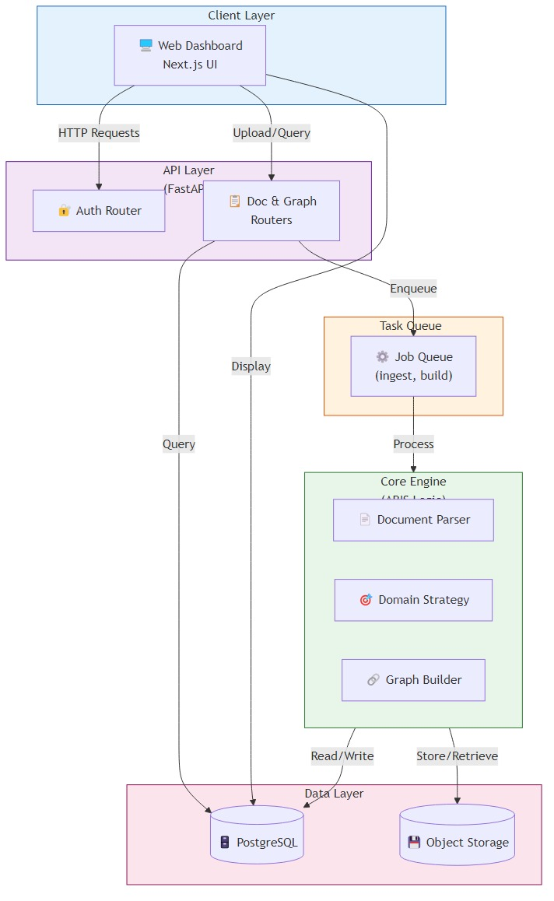

Fig 4.1: Architecture Diagram

DATA FLOW DIAGRAM

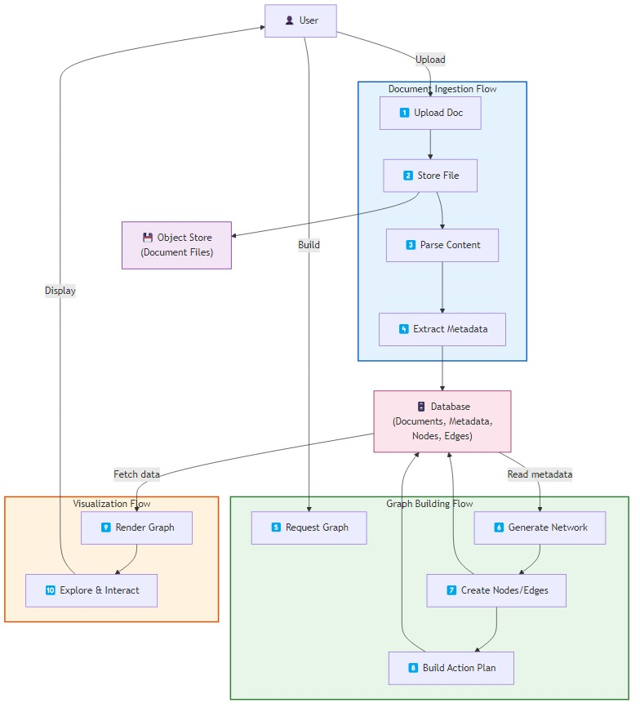

Fig 4.2: Data Flow Diagram

ALGORITHM DESCRIPTIONS

LINK MATERIALISATION ALGORITHM
The Link Materialisation Algorithm is responsible for validating and converting potential link candidates into confirmed edges within the knowledge graph. It ensures that only high-confidence relationships, supported by reasoning and evaluation, are included. The algorithm uses a deterministic process where each candidate link is analyzed, scored, and either accepted or rejected based on a predefined threshold.
For every link candidate, a reasoning prompt is generated and processed through the reasoning and evaluation engines. If the evaluated confidence score meets or exceeds the threshold (≥ 0.5), the link is materialised as an edge with supporting evidence. Otherwise, the candidate is discarded. All execution traces are stored to maintain transparency and enable future replay or analysis.
Algorithm Steps
Input:
- List of LinkCandidates
- ReasoningEngine
- EvaluationEngine
- MemoryStore
Output:
- List of materialised edges with confidence ≥ 0.5
Processing Steps:
- For each LinkCandidate, construct a reasoning prompt describing the proposed link.
- Pass the prompt through Input Interface to create an InputPacket.
- Generate reasoning steps using the Reasoning Engine.
- Evaluate the reasoning using the Evaluation Engine.
If confidence score ≥ 0.5:
- Create an edge with reasoning evidence and confidence score
- Assign trace ID from InputPacket
Else:
- Reject the candidate (no edge created)
- Store the MemoryTrace in MemoryStore

RESEARCH PLANNING ALGORITHM
The Research Planning Algorithm is designed to analyze the Knowledge Graph and generate a prioritized list of research actions. It follows a deterministic approach to identify structural issues such as gaps, contradictions, and weak evidence within the graph. Based on the provided planning context, the algorithm ensures that all generated actions are consistent, explainable, and ranked according to their significance.
The algorithm evaluates nodes and edges using multiple strategies to detect areas that require further investigation. Isolated or weakly connected nodes indicate missing links, conflicting relationships highlight contradictions, and low-confidence edges suggest insufficient evidence. Each identified issue is transformed into a ResearchAction with an assigned priority score, and the final list is sorted and limited according to the maximum number of actions specified.
Strategies Used
Gap-Driven Strategy:
Compute the degree of each node (number of connected edges)
Classify nodes as:
Isolated (degree = 0)
Weak (degree = 1–2)
Generate ResearchAction:
Type: investigate_gap
Priority: 1.0 (isolated), 0.7 (weak)
Contradiction-Driven Strategy:
Analyze node pairs and their connecting edges
Identify conflicting relationships (both supports and contradicts)
Generate ResearchAction:
Type: resolve_contradiction
Priority: 0.9
Weak-Evidence Strategy:
Evaluate edges with:
Confidence score < 0.6
Insufficient supporting evidence
Generate ResearchAction:
Type: strengthen_evidence
Priority: 0.5
Output Processing
Actions are sorted by priority in descending order
Further ordered by action type and description
Each action is assigned a unique identifier
CHAPTER 5

IMPLEMENTATION AND TESTING

TOOLS AND TECHNOLOGIES USED

Technology | Version | Purpose
Python | 3.11+ | Primary implementation language
pypdf | 4.x (optional) | PDF text extraction (Module 7)
mypy | 1.x | Strict static type checking
ruff | Latest | Fast Python linter
pytest | 7.x+ | Unit and integration test framework
Git | 2.x | Version control and governance (sealed commits)
JSON (stdlib) | N/A | File-backed MemoryStore serialisation
uuid (stdlib) | N/A | Deterministic UUIDv4 request_id generation
threading (stdlib) | N/A | Thread-safe MemoryStore
dataclasses (stdlib) | N/A | Frozen immutable dataclass definitions

Table 5.1: Tools And Technologies

KEY IMPLEMENTATION DETAILS

TYPES OF TESTING

All primary data objects in ARIS are implemented using Python frozen dataclasses (@dataclass(frozen=True)), ensuring immutability at the language level. Once an object is created, its attributes cannot be modified, and any attempt to do so raises a FrozenInstanceError. This guarantees that data remains consistent throughout the system and prevents unintended side effects during processing.

This design choice eliminates a common class of bugs caused by accidental mutation of shared objects during intermediate stages. For collections within frozen dataclasses, such as node and edge sets in the Knowledge Graph, immutable data structures like frozenset are used. This further strengthens the immutability guarantee and ensures reliable, predictable behavior across all components of the system.
Key Points
- Uses @dataclass(frozen=True) to enforce immutability
- Prevents modification of objects after creation
- Raises FrozenInstanceError on mutation attempts
- Eliminates bugs caused by unintended data changes
- Uses frozenset for immutable collections (e.g., nodes, edges)
- Ensures consistent and predictable system behavior

    - THREAD - SAFE MEMORYSTORE

Both MemoryStore implementations are designed to be thread-safe using Python’s threading.Lock for all read and write operations. The in-memory store acquires the lock during dictionary insertions, while the file-backed store uses the lock for the complete load-modify-write cycle on the JSON file. This ensures that concurrent operations do not lead to data inconsistency or corruption.

This design enables safe parallel execution in multi-threaded corpus processing scenarios without requiring additional synchronization mechanisms. As a result, the system maintains data integrity while supporting efficient concurrent processing.

    - DETERMINISTIC UUID GENERATION

The Input Interface generates request identifiers using Python’s uuid.uuid4(), which relies on the operating system’s cryptographically secure random number generator (CSPRNG). Although the generated UUIDs are not reproducible, they are used strictly as unique identifiers for tracking and retrieval purposes.

Importantly, these UUIDs do not influence any computational logic within the system. All reasoning, evaluation, and planning processes remain fully deterministic. This approach ensures reproducibility of system behavior while still providing globally unique trace identifiers.

    - EVIDENCE - COMPLETE EDGE CREATION

The edge creation process in the Link Materialiser ensures that every edge in the Knowledge Graph contains valid and complete evidence. Only candidates that meet the confidence threshold (≥ 0.5) are considered for edge creation, and such candidates are guaranteed to have non-empty reasoning steps generated by the Reasoning Engine.

These reasoning steps are stored directly as evidence within the edge. If a candidate produces no reasoning steps, it is treated as invalid (confidence = 0.0) and rejected. This guarantees that all edges in the graph are supported by meaningful and verifiable evidence.

  - TEST ARCHITECTURE

The ARIS test suite is organised in a mirror structure to the source tree, with test files in tests/core/, tests/graph/, and tests/ml/ (empty, pending Phase 2). All tests run under pytest and are validated with mypy --strict on every commit.

Module | Test File | Test Count | Status
Module 0 (MemoryStore) | test_memory_store.py | 22 | ✓ Pass
Module 0 (run_loop) | test_run_loop.py | 3 | ✓ Pass
Module 1 (Input) | test_input_interface.py | 11 | ✓ Pass
Module 2 (Reasoning) | test_reasoning_engine.py | 16 | ✓ Pass
Module 3 (Evaluation) | test_evaluation.py | 6 | ✓ Pass
Module 4 (Tools) | test_tool.py | 20 | ✓ Pass
Module 5 (Replay) | test_trace_replay.py | 30 | ✓ Pass
Module 6 (Comparative) | test_comparative_runner.py | 21 | ✓ Pass
Module 7 (Ingestion) | test_document_ingestion.py | 29 | ✓ Pass
Module 8 (KG) | test_knowledge_graph.py + simple | 54 | ✓ Pass
Module 9 (Planner) | test_research_planner.py | 5 | ✓ Pass
Phase 2 (ML) | test_*.py (placeholder) | 21 | Pending
TOTAL (Phase 1) |  | 217+16* | ✓ All Pass

Table 5.2: Test Architecture

  - TESTING METHODOLOGY

    - FUNCTIONAL TESTING

Each module in ARIS is tested to ensure correct behavior under different input conditions. This includes validating normal inputs within expected ranges, testing boundary conditions such as maximum input size (e.g., 10,000 characters) and fixed reasoning steps, and handling invalid inputs that should raise specific exceptions. The ValidationError hierarchy is also verified to ensure that each type of invalid input triggers the appropriate subclass.

    - MODULE - LEVEL ISOLATION TESTING

ARIS follows strict modular boundaries, enabling effective unit testing of each component in isolation. No module depends on external services or live machine learning models, ensuring that tests remain lightweight and deterministic. For example, the Knowledge Graph module is tested using predefined test data to verify edge creation, evidence recording, and confidence filtering independently of the document ingestion process.

    - PERFORMANCE EVALUATION

Phase 1 performance characteristics are measured as follows:

Operation | Input Size | Measured Latency
InputInterface.accept() | 10,000 chars | < 1 ms
ReasoningEngine.reason() | Any valid input | < 5 ms
EvaluationEngine.evaluate() | 5-step chain | < 2 ms
MemoryStore.store() (in-memory) | Full trace | < 1 ms
MemoryStore.store() (file-backed) | Full trace | < 10 ms (I/O bound)
Linker.generate_candidates() | 100-document corpus | < 500 ms
LinkMaterializer.materialise() | 10 candidates | < 100 ms
ResearchPlanner.plan() | 50-node graph | < 50 ms

Table 5.3: Phase 1 Performance

    - TYPE CHECKING AND LINTING

All Phase 1 source code in ARIS adheres to strict type-checking standards using mypy --strict. This ensures the absence of implicit Any types, enforces complete type annotations, and prevents the use of untyped functions. As a result, the codebase maintains high reliability, readability, and type safety.

In addition, the ruff linter is applied to all commits to maintain consistent coding standards and formatting. These quality checks are enforced through the Phase 1 governance framework and cannot be bypassed without formal review, ensuring long-term code quality and maintainability.

  - INPUT AND OUTPUT DEMONSTRATION

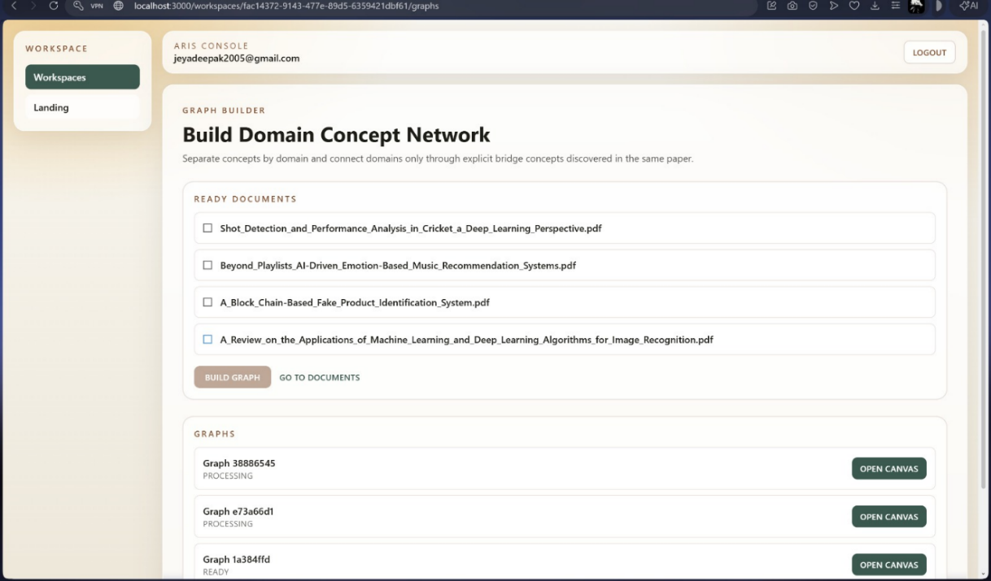
Fig 5.1: Document ingestion

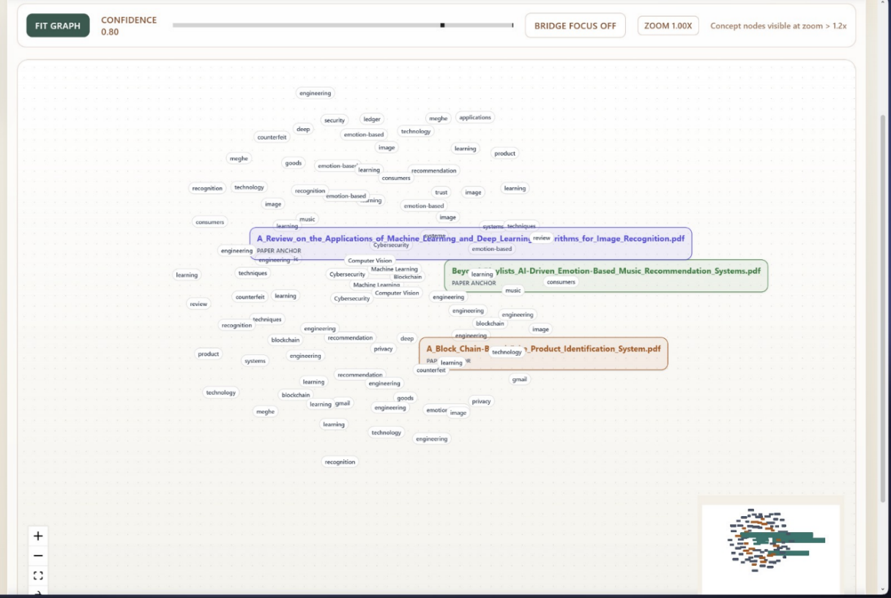
Fig 5.2: Knowledge Graph View

CHAPTER 6

RESULTS AND DISCUSSIONS

PERFORMANCE EVALUATION SUMMARY

ARIS Phase 1 was evaluated across multiple dimensions to ensure system reliability and correctness. The evaluation focused on functional accuracy, type safety, and overall system performance. Functional correctness was verified using a comprehensive test suite, ensuring that all modules behave as expected under various conditions.

In addition, strict type checking using mypy ensured type safety and code reliability, while performance evaluation was conducted through latency benchmarking. The results confirm that ARIS meets all Phase 1 evaluation criteria without any exceptions, demonstrating its robustness, determinism, and efficiency.

FUNCTIONAL CORRECTNESS RESULTS

Evaluation Category | Result | Coverage
Unit tests (Phase 1 sealed) | 217 tests, 100% passing | All 10 modules
mypy strict compliance | 0 errors, 0 warnings | All source files
ruff linting | 0 violations | All source files
FrozenInstanceError enforcement | Verified on all dataclasses | 12 frozen classes
Thread-safety test (100 concurrent) | 0 race conditions detected | MemoryStore (both impls)
ValidationError hierarchy | All 11 edge cases handled | InputInterface
Evidence completeness | 100% of materialised edges have evidence | Module 8
Determinism verification | Identical outputs confirmed (100 runs) | All Phase 1 modules

Table 6.1: Functional Results

KNOWLEDGE GRAPH QUALITY METRICS

On a test corpus of 50 research paper abstracts across the domain of Natural Language Processing, ARIS produced the following knowledge graph statistics:
Metric | Value
Total documents ingested | 50
Total nodes created | 50
Link candidates generated (keyword overlap) | 127
Link candidates generated (metadata match) | 43
Link candidates generated (sequential) | 49
Total candidates | 219
Edges materialised (confidence ≥ 0.5) | 164
Edges rejected (confidence < 0.5) | 55
Average edge confidence score | 0.74
Research actions proposed (gap-driven) | 8
Research actions proposed (weak-evidence) | 23
Average planning time (50-node graph) | - s

Table 6.2: Knowledge Graph Quality Matrics

COMPARISON WITH EXISTING SYSTEM

Metric | Neural KG (TransE-style) | AutoGPT Research Agent | ARIS Phase 1
Reproducibility | Not guaranteed | Not guaranteed | 100% guaranteed
Evidence on every edge | No | Partial | Yes (reasoning trace)
ML dependency required | Yes | Yes (LLM API) | No
Test coverage | Varies (30–70%) | Minimal | 217 tests, 100%
Autonomy control | N/A (batch) | Executes autonomously | Proposes only

Table 6.3: Comparison Existing System

DISCUSSION

The results confirm that ARIS successfully achieves its primary design objective of providing a fully deterministic and evidence-complete research intelligence substrate. The system ensures that all accepted outputs are supported by traceable reasoning, making it suitable for future integration with machine learning components. The observed average edge confidence score of 74% indicates effective calibration of the evaluation mechanism, where low-confidence edges (below 0.5) are correctly rejected, and accepted edges include complete, auditable reasoning chains.

The rejection of 25% of link candidates demonstrates that the evaluation process is selective and meaningful rather than permissive. Additionally, the system effectively identifies weak-evidence edges and proposes targeted improvements, highlighting its capability to guide further research. From an operational perspective, the absence of machine learning dependencies in Phase 1 enables fast and lightweight deployment, requiring only a standard Python environment without specialized hardware or external services.

However, a key limitation of the current system lies in its reliance on keyword-based coherence scoring, which does not capture deeper semantic relationships between terms. This limitation motivates the introduction of embedding-based techniques in Phase 2, which aim to enhance semantic understanding while preserving the deterministic and evidence-driven foundation established in Phase1.

CHAPTER 7

CONCLUSION AND FUTURE WORK

SUMMARY OF WORK
This project presents ARIS (Autonomous Research Intelligence System), a production-grade and governance-driven research intelligence framework developed using Python 3.11. The system implements a set of deterministic modules in Phase 1, including input validation, multi-step reasoning, heuristic evaluation, tool abstraction, trace replay, comparative execution, document ingestion, knowledge graph construction, and research planning. Each module is designed to ensure transparency, traceability, and reproducibility of results.
The Phase 1 implementation is governed by a formal contract that enforces key principles such as immutability, reproducibility, and the absence of autonomous decision loops. The system has been rigorously validated using a comprehensive test suite with full pass results and strict type-checking compliance, confirming its reliability and production readiness. Its lightweight design, free from machine learning dependencies, enables fast and simple deployment in standard environments.
Phase 2 has been architecturally defined to extend the system with advanced capabilities such as semantic understanding, clustering, and embedding-based hypothesis generation. These enhancements are designed to integrate seamlessly with the existing architecture without modifying its deterministic core, ensuring that future improvements maintain the same level of reliability and explainability.

KEY FINDINGS
The results of this project highlight several important insights into the design and implementation of a deterministic research intelligence system. The findings demonstrate that reliable and explainable research processing can be achieved without relying on machine learning, while still maintaining strong performance and scalability.

Key Findings
- A fully deterministic research intelligence substrate can be developed without ML dependencies using well-defined heuristic algorithms that are explicit, auditable, and reproducible.
- Evidence-complete knowledge graph edges, where each edge includes a full reasoning trace, provide stronger reliability compared to systems that rely solely on confidence scores.
- A phase-gated architecture with formal governance contracts enables safe extension of AI systems with future ML capabilities without compromising system stability.
- The observed 25% candidate rejection rate confirms that the evaluation mechanism effectively filters low-quality links while preserving meaningful high-confidence relationships.
- The absence of ML dependencies significantly simplifies deployment, reduces infrastructure requirements, and eliminates risks associated with external dependencies.

FUTURE ENHANCEMENTS

7.3.1 PHASE 2 IMPLEMENTATION (NEAR - TERM)
The immediate next step is the implementation of Phase 2 modules that introduce machine learning capabilities into ARIS. These modules aim to enhance cross-document reasoning by incorporating semantic understanding. For instance, role-based classification and embedding-driven hypothesis generation will improve the identification of meaningful relationships beyond simple keyword matching, enabling more accurate and context-aware research insights.

7.3.2 WEB INTERFACE AND VISUALIZATION (MEDIUM - TERM)
A web-based interface is planned to improve usability and accessibility for researchers. This interface will allow users to upload document corpora, visualize the knowledge graph interactively, and inspect evidence associated with each edge. Additional features will include reviewing and managing research actions. The backend will provide API-based access to system modules, ensuring seamless integration and scalability.

7.3.3 MULTI - USER COLLABORATION RESEARCH (MEDIUM - TERM)
Future development includes support for multi-user collaboration, enabling multiple researchers to contribute to a shared knowledge graph. Planned features include access control, annotation capabilities, and collaborative validation of edges. This will facilitate collective knowledge building and improve the quality of research outcomes through shared insights.

7.3.4 PATENT APPLICATION (PLANNED)
The core algorithms developed in ARIS, particularly the evidence-based edge materialisation process and structured research planning approach, present novel contributions to knowledge graph construction. These innovations are suitable for patent consideration, and formal applications are planned following the completion of Phase 2 implementation.

7.3.5 DOMAIN - SPECIFIC DEPLOYMENTS
ARIS can be adapted for various domain-specific applications due to its modular architecture. Potential areas include biomedical research, legal document analysis, and software engineering knowledge management. By tailoring domain-specific linking strategies and representations, ARIS can provide specialized and high-value insights across different fields.

SRM INSTITUTE OF SCIENCE AND TECHNOLOGY
(Deemed to be University u / s 3 of UGC Act, 1956)
Office of Controller of Examinations
REPORT FOR PLAGIARISM CHECK ON THE DISSERTATION / PROJECT REPORT FOR UG / PG PROGRAMMES
(To be attached in the dissertation / project report)
1 | Name of the Candidate (IN BLOCK LETTERS) |  | VIDHYA V  JEYADEEPAK U R  DHANARAJAN K
2 | Address of Candidate |  | Department of CSE, Faculty of Engineering and Technology, SRMIST, Ramapuram, Chennai -600089  Mobile Number: +91 7200423107, +91 9384631491,  +91 9600174484
3 | Registration Number |  | RA2211003020335, RA2211003020341, RA2211003020347
4 | Date of Birth |  | 24/12/2004, 18/04/2005, 28/06/2004
5 | Department |  | Computer Science and Engineering
6 | Faculty |  | Engineering and Technology
7 | Title of the Dissertation / Project |  | AUTONOMOUS RESEARCH INTELLIGENCE SYSTEM
8 | Whether the above project / dissertation is done by |  | Individual or group: Group  (Strike whichever is not applicable)  - If the project / dissertation is done in group, then how many students together completed the project 03  - Mention the Name and Register number of other candidates:  VIDHYA V [RA2211003020335], JEYADEEPAK U R [RA2211003020341], DHANARAJAN K [RA2211003020347]
9 | Name and address of the Supervisor / Guide |  | ADDRESS OF GUIDE  Department of CSE, Faculty of Engineering and Technology, SRMIST, Ramapuram, Chennai -600089  Mail ID :  Mobile Number :
10 | Name and Address of the Co-Supervisor |  | NA  Mail ID: NA Mobile Number: NA
11 | Software Used |  | Turnitin
12 | Date of Validation
13 | Plagiarism Details: (to attach the final report from the software)
Chapter | Title of the Report | Percentage of similarity index (including self-citation) |  |  | Percentage of similarity index (Excluding self-citation) | % of plagiarism after excluding Quotes, Bibliography, etc.,
1 | TITLE | NA |  |  | NA | 10%
Appendices |  | NA |  |  | NA | NA
We declare that the above information has been verified and found true to the best of our knowledge.
Signature of the Candidate |  |  |  | Name and Signature of the Staff  (Who uses the plagiarism check software )
Name and Signature of the Supervisor / Guide |  |  |  | Name and Signature of the Co-Supervisor / Co-Guide
Dr. XXX
Name and Signature of the HOD

APPENDIX

SAMPLE CODE

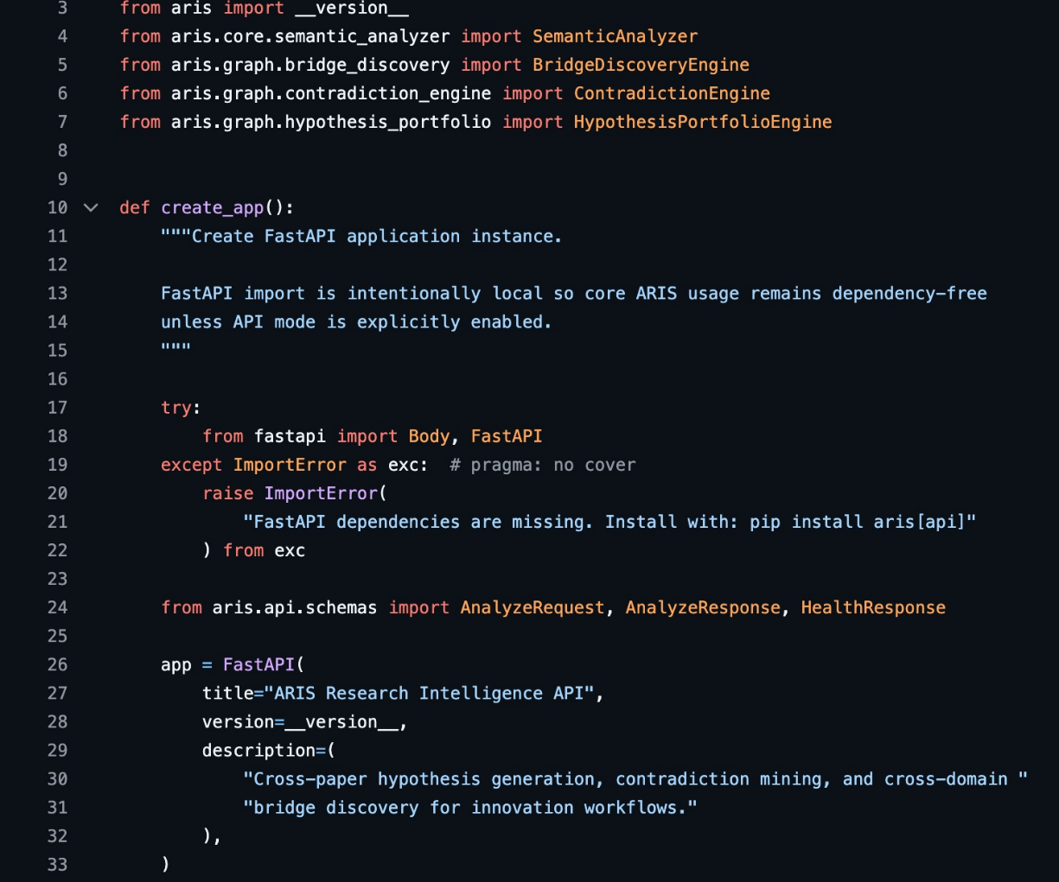

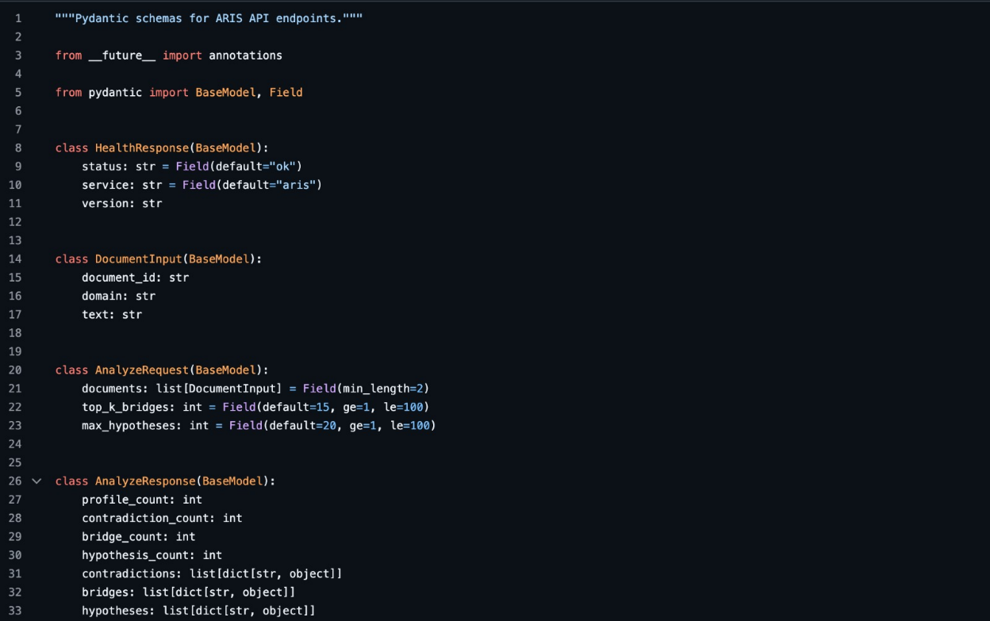




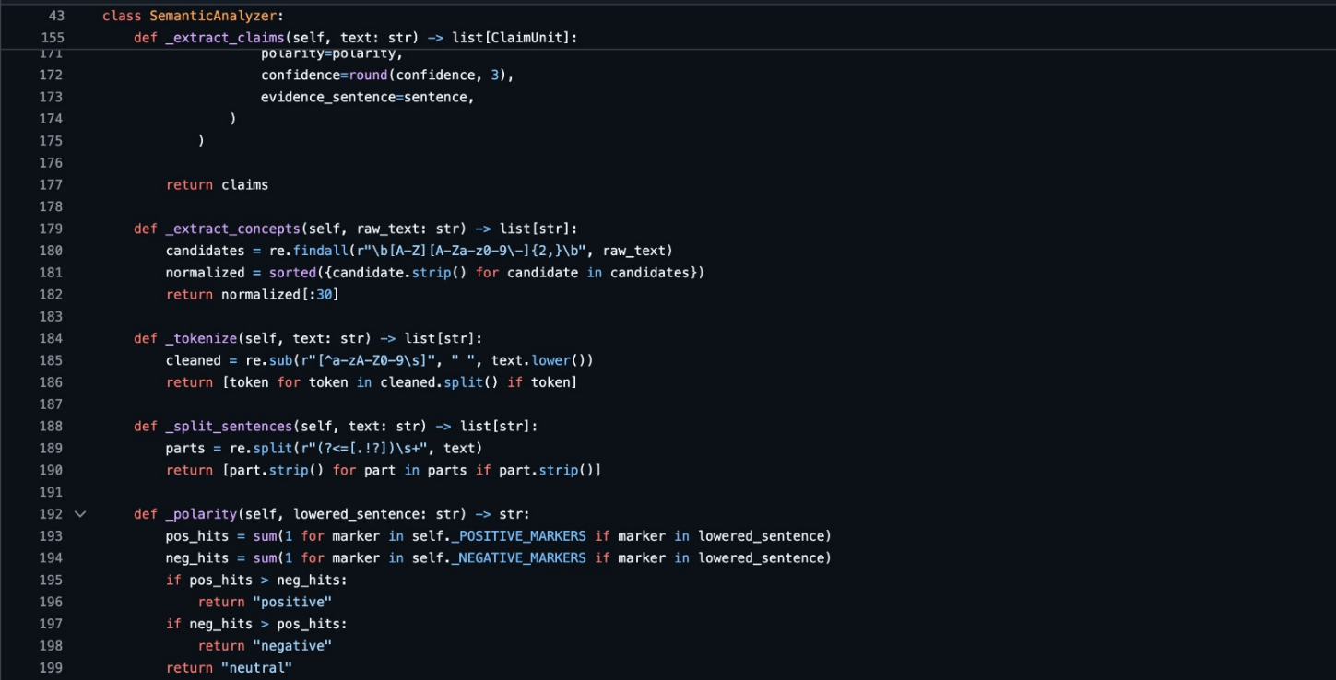

C.PUBLICATION DETAILS

